Paleokastritsa Donkey Track

This is a walk of around an hour up a steep hill through the woods from Paleokastritsa to Lakones.
Despite the climb, the walk is well worth the effort as you can see from the photos.
It is not a long walk but very rewarding.
We have personally done it 3 times now and each time holds special memories.
Make sure you take plenty of water as it can get very hot in the summer months.
The location of the walk is in the North-Western side of the island in the small pretty coastal village of Paleokastritsa.

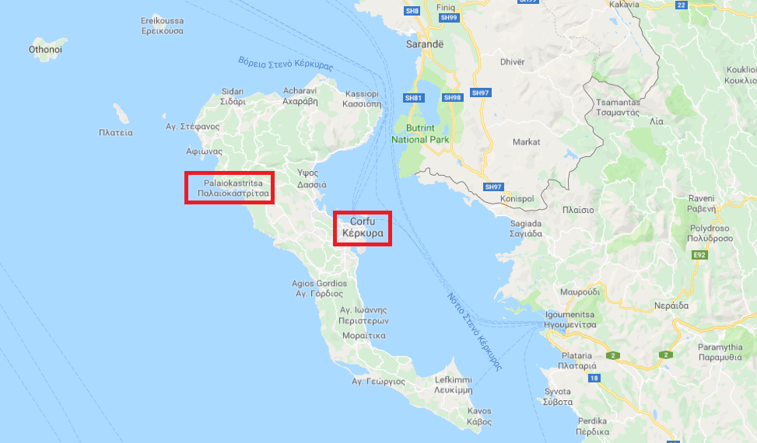

The walk itself starts opposite the Apollon Hotel on the Agios Spiridon Beach.
With the beach behind you and facing the Apollon Hotel, walk to the right up the slight incline to the supermarket on your right (approx. 100m).

Immediately after the supermarket, take a left turn on the tarmac road (see below)
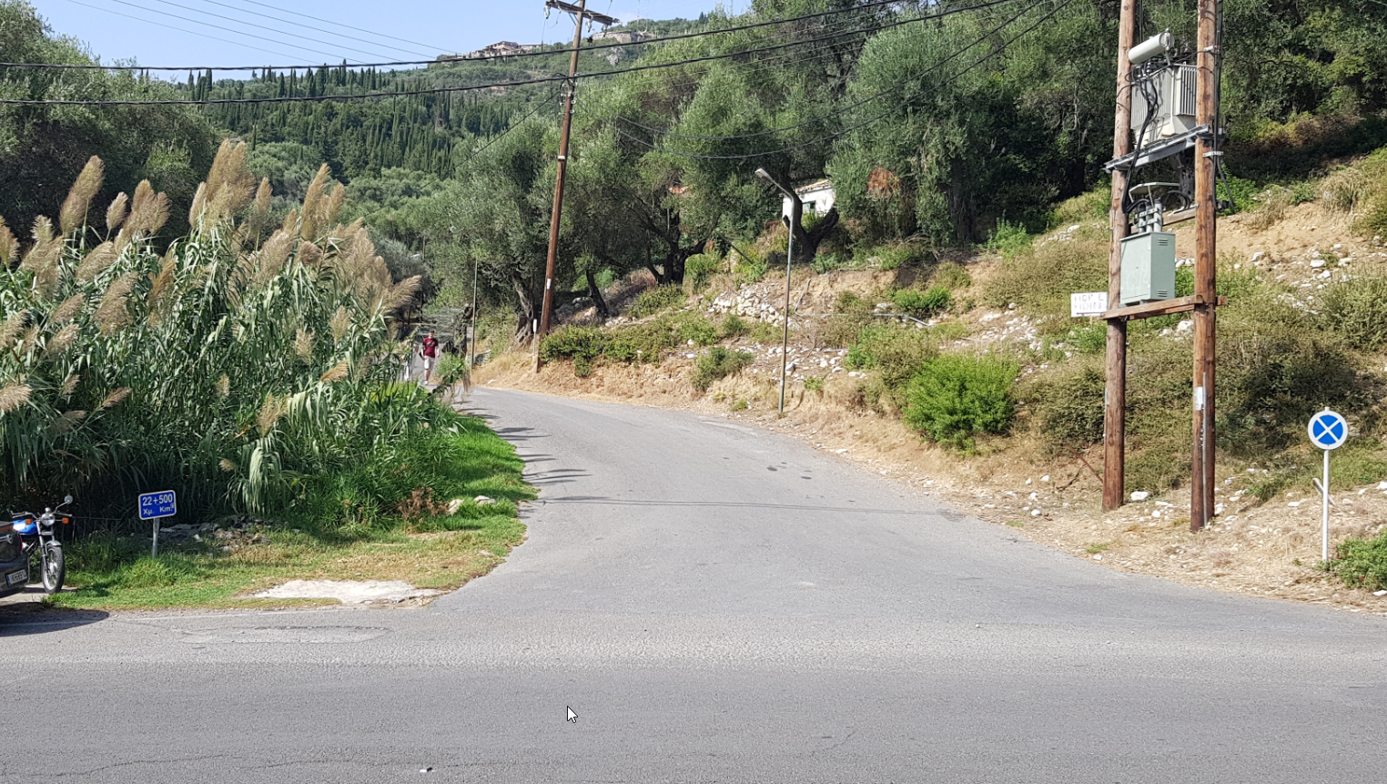
After approx. 50m, take the right fork up the hill…
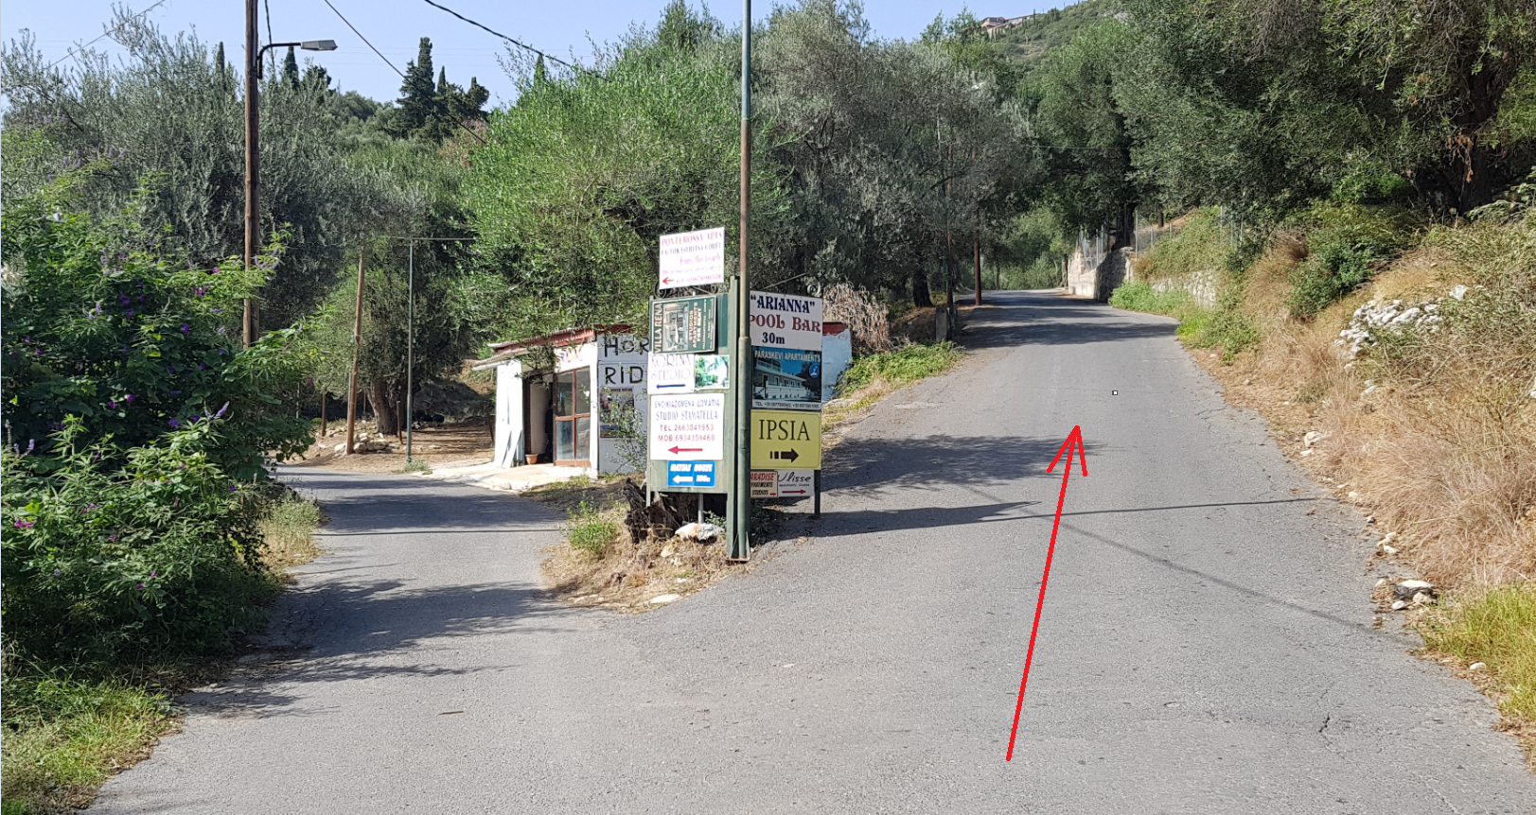

Continue up the path past the Arianna Pool Bar…
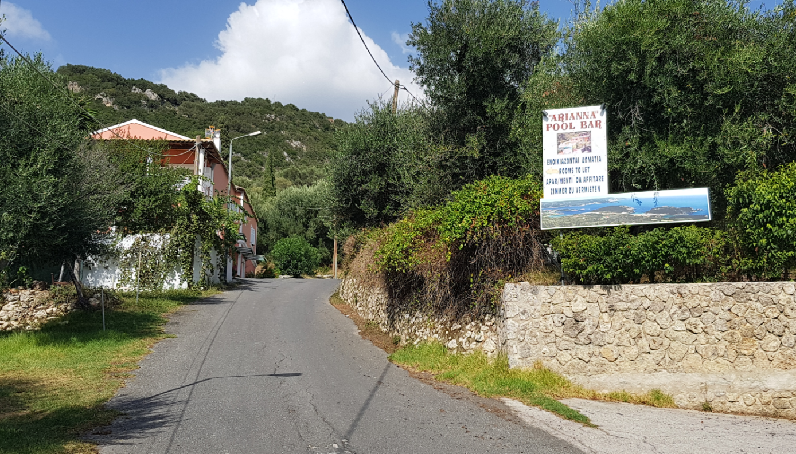

Continue up the steep incline (its well worth it in the end) to the brow of the hill on the tarmac road.

At the brow of the hill to the left is the start of the Donkey Track (currently (2018) faintly signposted to ‘Path to Lakones’)
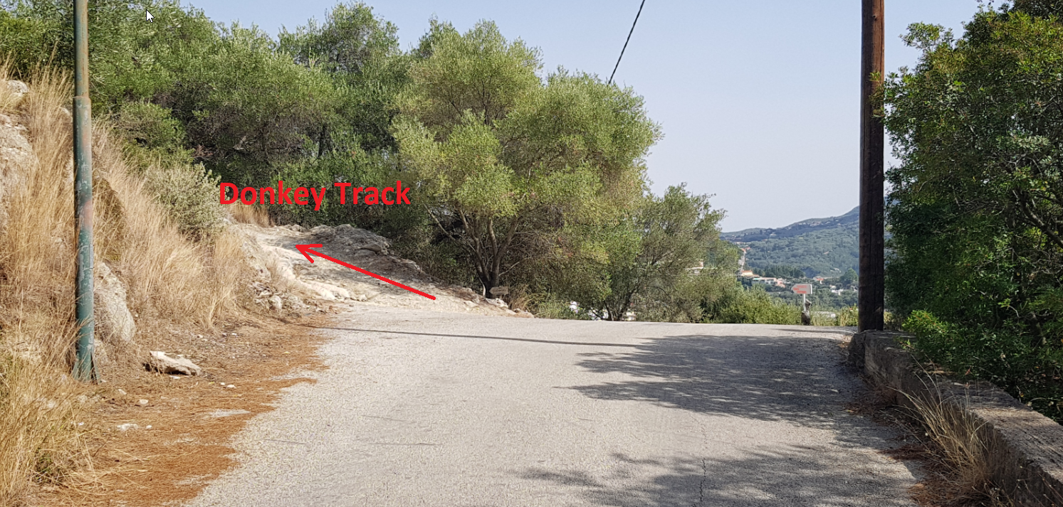

The track itself is easy to follow keeping on the obvious footpath and passing below a large crag on the left…
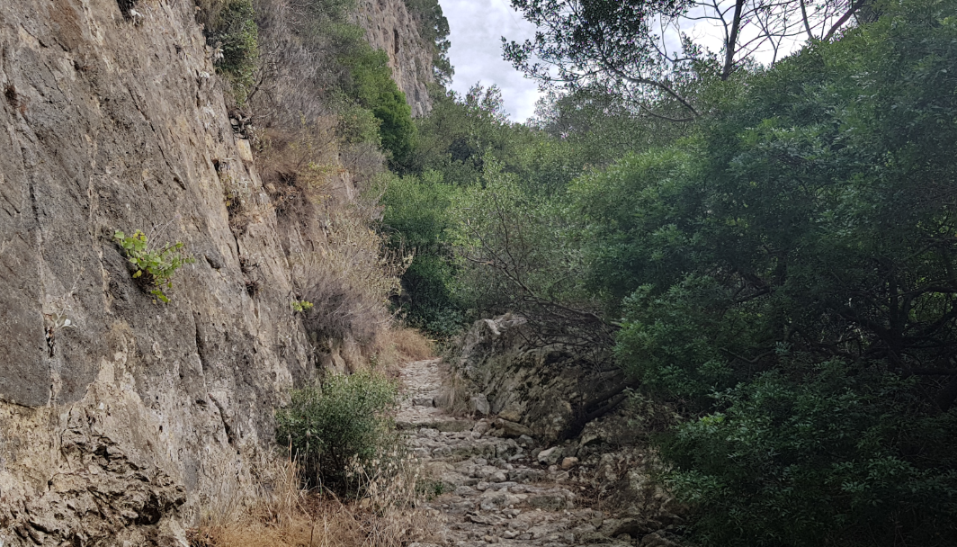

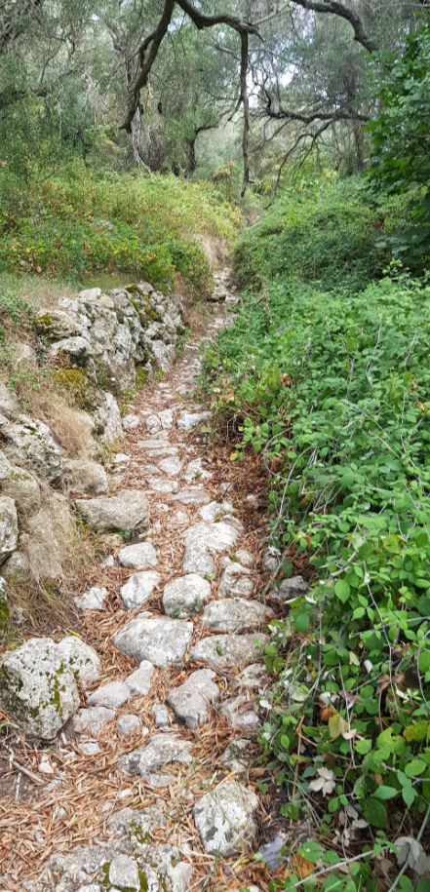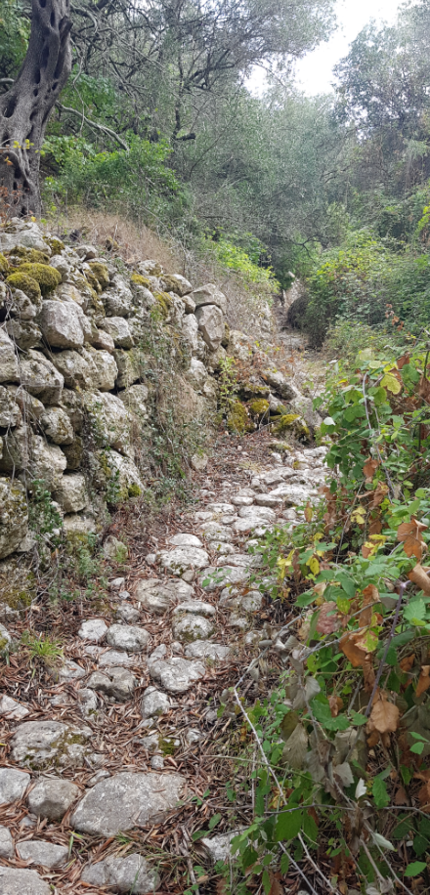

Shortly, you will meet a small concrete pipe diverting any water in the stream under the small concrete road.

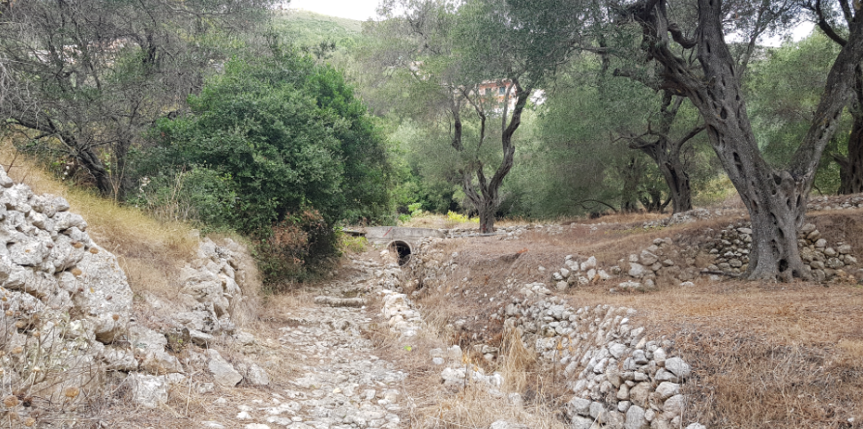

Cross over the pipe and immediately turn left.

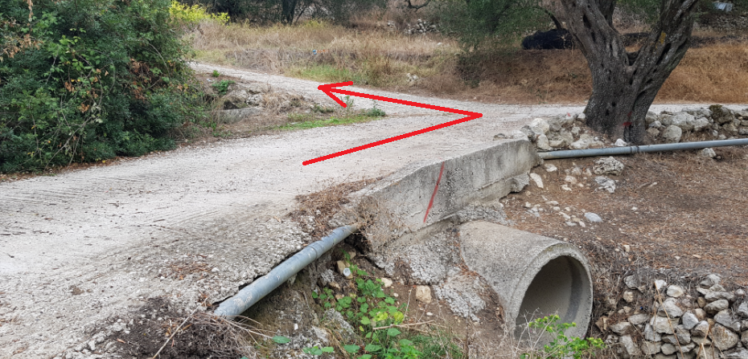

Pass the small gate and continue up the obvious winding stony path.

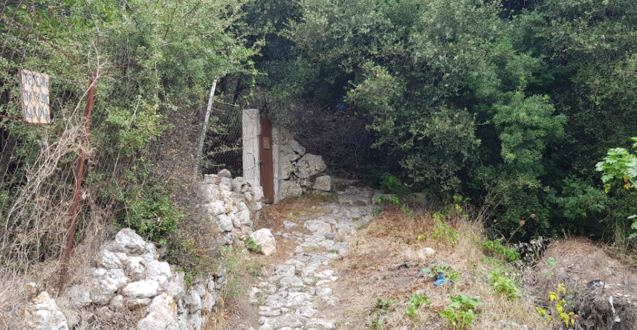

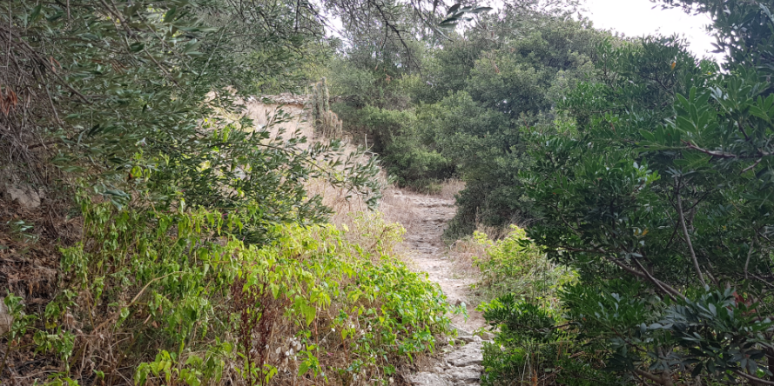

You will soon reach some stone steps just before the village of Lakones.

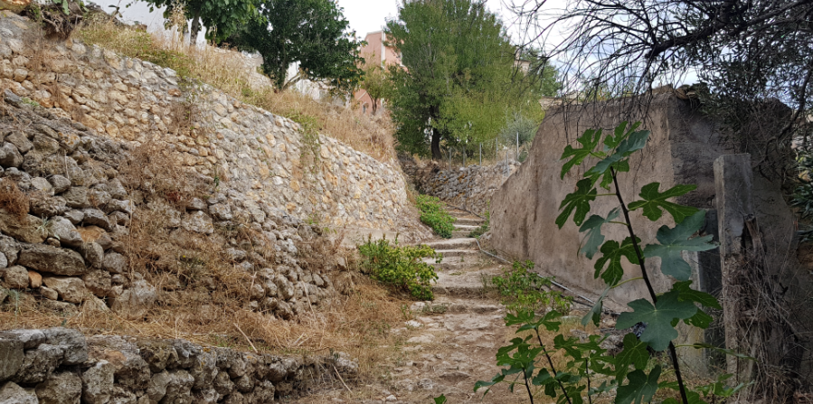

Which soon turn into paved flags.

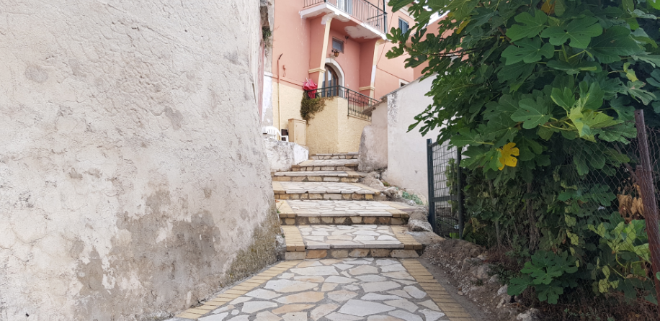

Go up the paving and turn left at the top following ‘Lear’s Path’.

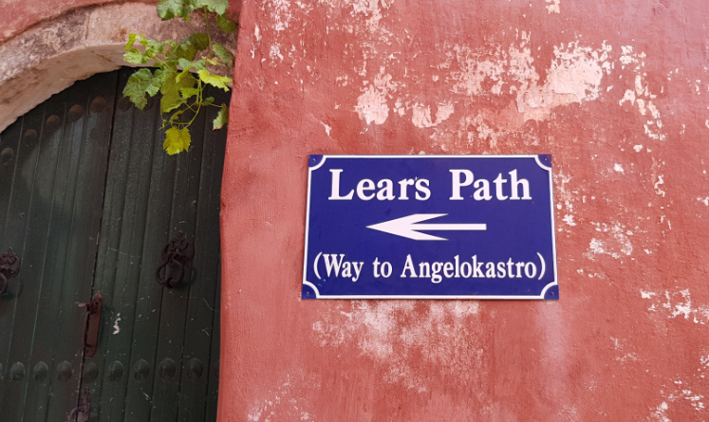

This will take you to the main road through the village where you can sometimes purchase refreshments.
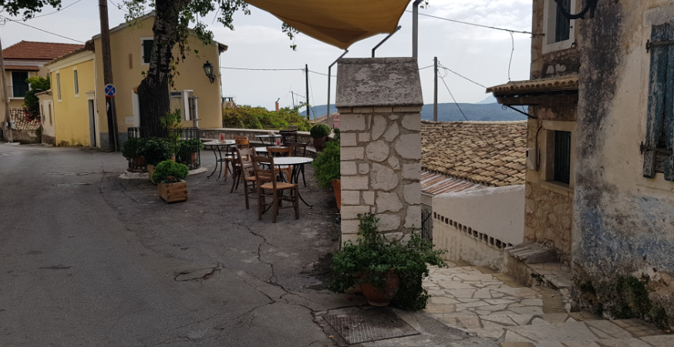
As refreshing it may seem, try to resist as another 15 minutes on the road there are other options for food and drinks with stunning views but there is no reason to refresh yourself here AND further along the road.

Upon meeting the road, turn left and follow it through the village.

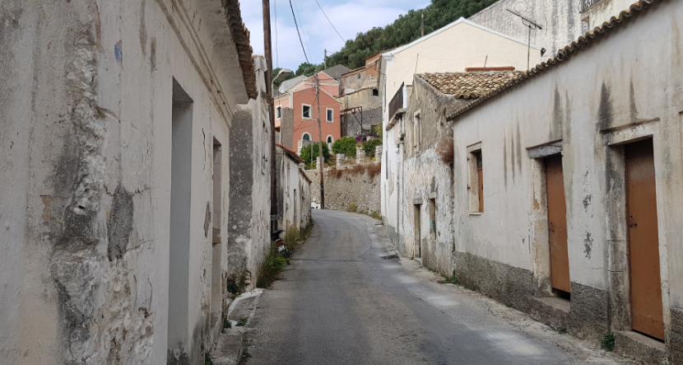

and the scenic views of the bays below around Paleokastritsa slowly unfold themselves.

A short walk along the road (approx. 15 mins) will take you to the Bella Vista restaurant and a little further is The Golden Fox.
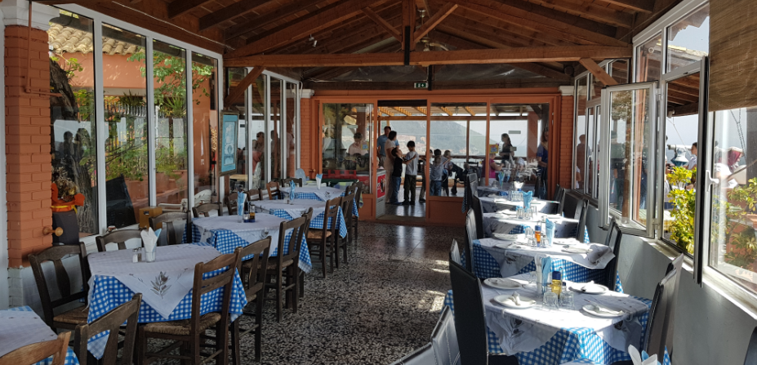

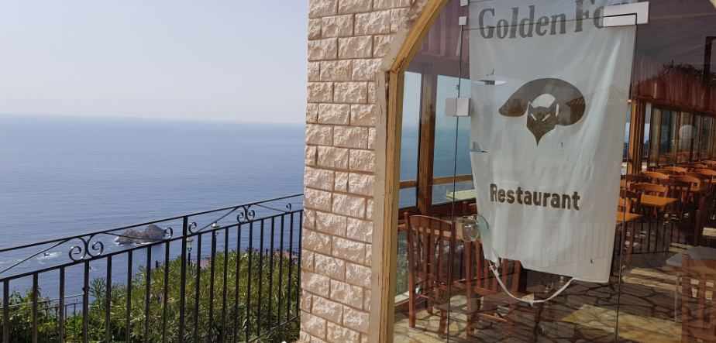

Either place is good for food and drinks or just an ice cream but savour the views… they are stunning.

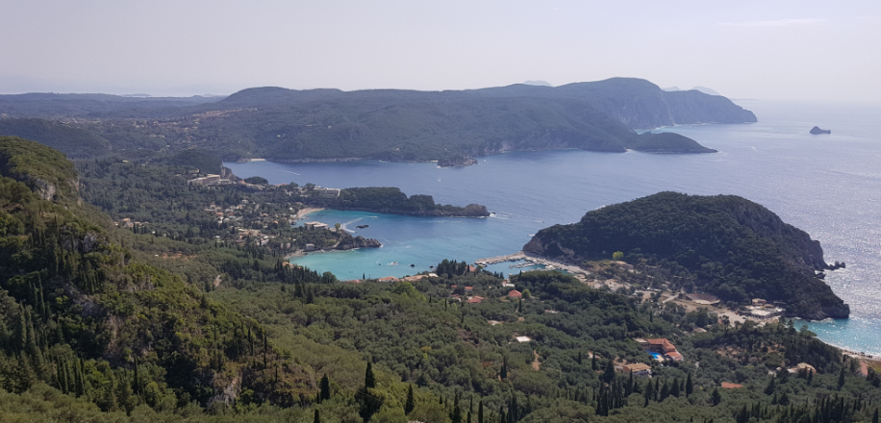

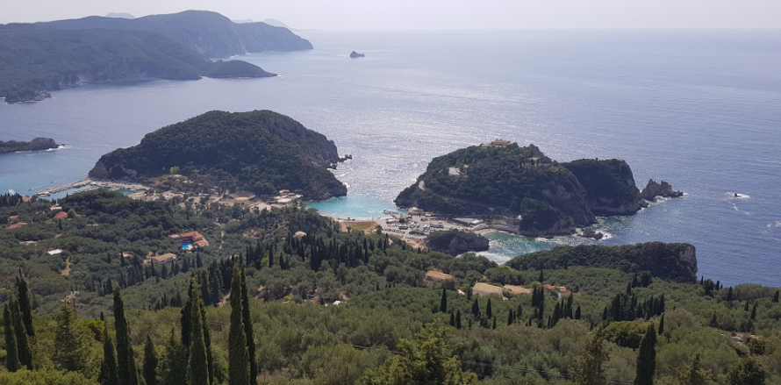

Return by retracing the steps you took to get up here via the donkey track.

ENJOY!

There is a further option to carry on walking along the road to the old ruins of ‘Angelokastro’
This is a hilltop castle ruins which it must be said is still a fair walk on the road with no path (but not very busy) but do a little research into what is there if you feel the need to visit it.

